
भारतीय जीवन बीमा निगम, जबलपुर मण्डल
LIFE INSURANCE CORPORATION OF INDIA, JABALPUR DIVISION
Ref.:-Sales/Tender/2025-26/03 Date:19.06.2025

ANNEXURE : A

LIFE INSURANCE CORPORATION OF INDIA- JABALPUR DIVISION
ANNEXURE : A Ananda Trophy
S.No |  | QUANTITY | Rate per unit
1 | 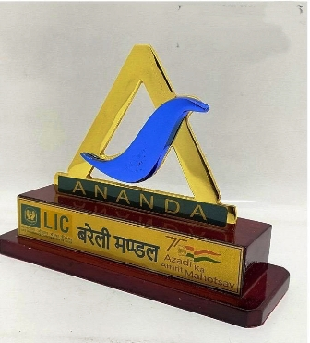 | UP TO 100
1 |  | 101 TO 300
1 |  | 301 TO 500
1 |  | 501 TO 750
1 |  | 751 TO 1000
1 |  | 1000 & ABOVE
2 |  | UP TO 100
2 |  | 101 TO 300
2 |  | 301 TO 500
2 |  | 501 TO 750
2 |  | 751 TO 1000
2 |  | 1000 & ABOVE
3 |  | UP TO 100
3 |  | 101 TO 300
3 |  | 301 TO 500
3 |  | 501 TO 750
3 |  | 751 TO 1000
3 |  | 1000 & ABOVE
(ALL RATES ARE EXCLUSIVE GST)

Seal and Signature vendor

